8

THURSDAY, OCTOBER 22, 2020

All the news

of your region
live 24 hours on

www.lameuse.be

LIÉGEOISE REGION – HEALTH CRISIS

Discover the

Karrré reports

Go to the Facebook page

- Karrré» to discover the latest video reports of your newspaper la Meuse.

Prostitution, the forgotten sector of the health crisis

The closure of bars plunges undeclared prostitutes into even greater precariousness

with the health crisis, Ail has a sector that
We tend to forget: that of prostitution. If the workers of the

At the time of writing, Rue Marnix may remain or-green until 11 p.m., the prosti-tuées of Rue Varin and the N3 had to close their doors for a month. A farm which plunges those who are not declared in a precariousness even more important.

They are doing the oldest job in the world and today they feel forgotten by the government in the context of this health crisis. The latest government directives have had the effect of shutting down

– or at the very least severely curb the activities of sex workers on Va-rin Street, Marnix Street and N3. Indeed, the only prostitutes who can still work in part are on Mar-nix Street. “They have to close at 11:00 p.m., to respect the curfew,” Seraing told us. The Bourg-Mestre is responsible for public safety, but this is a public health issue. He therefore appealed to the Governor of the Province, as well as to the Minister of Federal Power, for a protocol to be put in place with regard to the prostitution sector.”

CLOSED LIKE HORECA

Sex workers who generally work in the windows on Varin Street and in

the champagne bars of the N3 have, on their side, completely closed shop, as confirmed to us at the ASBL Icar. The establishments which shelter their professional activity are actually consumer bars. They are therefore linked to the measures in force in Horeca, and are closed for one month.

Whether they are partially open or closed, these places are essential for girls to

On Marnix Street, maybe five or six out of 50 are reported. A large majority will not receive financial assistance”

exercise their profession. Many of them are now plunged into a precariousness already experienced last March. Audrey (borrowed first name) works in Rue Marnix in Seraing for nine months. Today, she can benefit from the uneasy right, but this was not the case during the first confinement.

- I was without income for three months,” she says. Here, I will be entitled to it because I am independent-dependent since more than two

Sex workers on Varin Street and N3 have completely closed shop. Laura Hollange
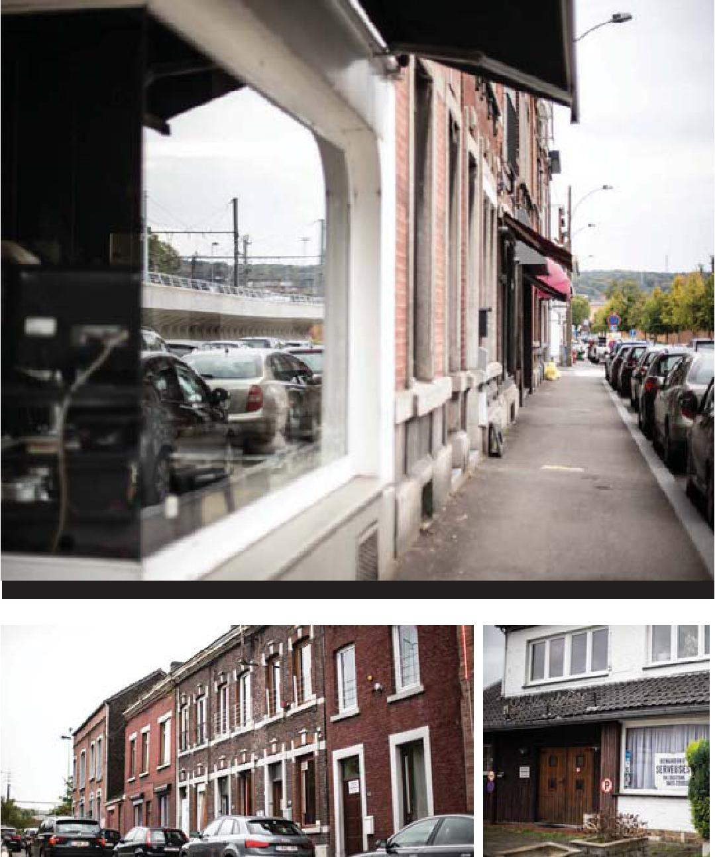

For the moment, Marnix street remains open until 11 pm. Laura Hollange |  | The bars of Awans. L.H

years now, which was not the case in March.”

But Audrey is also thinking of the other colleagues, the majority of them, who will not be able to benefit from this financial assistance. For in the midst of prostitution-

- There is a decrease
of approximately 50% of
the clientele. People are afraid and have less money.”

On Marnix Street, there are about 50 women workers,” says Audrey. “

- There are maybe five or six that are reported.” On the support side of the non-profit organisations, it is preferable not to address the question of the precarious status of women in prostitution. “For all these girls, it will be difficult.” After the first lockdown, the prostitutes were able to resume their activities in June. “But we never fully reopened,” says our witness. “There is a decrease of about 50% of the clientele. On the one hand, people are afraid and on the other hand, they have less money.”

And if the girls of Marnix Street can still, at the time of writing, continue to practice, they may soon have to comply with a common rule… -
ALLISON MAZZOCCATO

BOIS DE L'ABBAYE – CORONAVIRUS

Accessible CHBA Drive-in
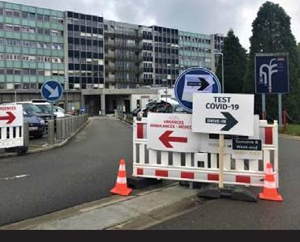

The «Drive-in» Covid screening of the Bois de l'Abbaye Hospital (CHBA) will be well accessible again from Mon-Di 26 October.

However, new measures have been taken to ensure a significant influx of vehicles: As announced, the

- Drive-in» CHBA Covid-19 screening will again be available from Monday 26, but on the basis of new practical procedures», announces this Wednesday, the Centre Hospitalier du Bois de l'Abbaye.

- This new organization will aim to avoid the massive influx of cars near the hospital, disturbing the public order and tranquility of the shore-

The European Commission, Mr President-in-Office of the Council of Ministers, has been working with the European Commission on a number of issues.

BY APPOINTMENT ONLY Concretely, the PCR tests at CHBA are now only by appointment. Appointments should be made by telephone at 04/338.77.77. The call center will be available from Thursday, October 22, from Monday to Friday between 8:30 am and 4:30 pm. The Drive-in will be open from Monday to Friday from 12:30 to 16:30 from this Monday 26 October.

It will be closed on weekends and will be accessible to pedestrians. For ease of reference, the hospital requests to present itself on the day of its appointment with its confirmation SMS, its ID card and three stickers.

It is important to respect scrupulously the time of the appointment in order to streamline the organization of the day. For those who do not have a mobile phone, a verification on the nominal list will be carried out. No PCR test will be performed without an appointment.

WHO CAN BENEFIT FROM IT? Only persons presenting

symptoms and with a medical prescription can benefit. Asymptomatic high-risk contacts and travellers from red areas (considered “high-risk” by the au-to-assess form) will not be tempo-rally tested, and this trial will only take place on 15 November.

Anyone over 6 years of age (high-risk contact or not) who develops possible symptoms of COVID-19 should be tested. It is also important to note that preventive tests which do not give indications (for example, at the request of the employer, at the request of the employer)

It will be well accessible again this Monday, October 26. D.R

bender, high risk contact | can not be performed so much
asymptomatic that is not | that the testing capability will be under
not a health professional | pressure. -
or low risk contact) do not | R.C

EDITOR:
Gaspard GROSJEAN

THE MEUSE
LIÈGE

Bd de la Sauvenière, 38 - 4000 Liège redliege.lameuse@sudpresse.be www.lameuse.be

DIRECTOR GENERAL: Pierre LEERSCHOOL

EDITOR: Demetrio SCAGLIOLA
ASSOCIATE EDITOR: Rodolphe MAGIS
SECRETARY-GENERAL OF THE EDITORIAL BOARD: Philippe KÜSTER

HEAD OF SPORTS SERVICES: Grégory BAYET
DIRECTOR OF DEVELOPMENT: André THIEL

SUDPRESSE S.A., RUE DE COQUELET, 134 - 5000 NAMUR

RESPONSIBLE EDITOR: Patrick HURBAIN

CUSTOMER SERVICE Monday to Friday from 8 am to 6 pm - Saturday from 8 am to 12 pm OTHER SERVICES
078/15.75.75 (zonal tariff) |  |  | 070/21.10.10
E-MAIL: subscriptions@sudpresse.be |  |  | • OBITUARY NOTICES • CLASSIFIEDS
All our subscription offers on www.jemabonne.be |  |  | •COMMERCIAL ANNOUNCEMENTS •GENERAL DRAFTING

YOUR ADVERTISEMENT IN THIS JOURNAL: publicite@sudpresse.be

8

